TEACHER: MWALE CHI

DESIGN AND TECHNOLOGY DEPARTMENT
LESSON PLAN

SUBJECT: DESIGN AND TECHNOLOGY CLASS:…… … DATE:……/……./20…. DURATION:………….
BOYS:…………………… GIRLS ………………………………………. TOTAL OF PUPILS…
TOPIC: ORTHOGRAPHIC PROJECTION SUBTOPIC: ORTHOGRAPHIC PROJECTION
LEARNING OUTCOMES LSBAT

Describe the Principle Planes in Orthographic Projection
- Construct simple objects from Isometric to Orthographic Projection without hidden details.
RATIONALE

KNOWLEDGE:
- Principle planes: (Vertical, Horizontal and Side Vertical Planes),
- Front, Plan, End elevations, Hidden details, Dimensioning,
- First and Third Angle Projections, SKILLS:
- Identification, Demonstration, Accuracy, Drawing, Communication VALUES:
- Curiosity, Problem solving, Critical thinking, Application, Accuracy, Team work
TEACHING AIDS
PART | LESSON CONTENT | METHODOLO GY | LEARNER ACTIVITY
introduction | - Recap on the previous lesson | Questions and answers | Provide answers
Developme nt | ORTHOGRAPHIC PROJECTION  Orthographic projection is a means of representing three-dimensional objects in two dimensions  - Describe the Principle Planes in Orthographic Projection  - First angle projection  - Third angle projection  - Symbol used in first and third angle projection  - Construct simple objects from Isometric to Orthographic Projection without hidden details. | Questions And Answers  Demonstration  V/E | Taking note of important points  Provide answers
Application | CLASS EXERCISE  Draw the following views in first angle projection (D & T page )  - The Front elevation looking in the direction of FE  - The End elevation looking in the direction of EE  - The Plan looking in the direction of P | Questions And Answers | Provide answers
Conclusion | - Recap on the main steps and points | V/E
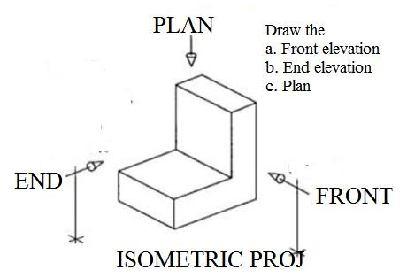
LESSON EVALUATION

TEACHER: MMWALE C

DESIGN AND TECHNOLOGY DEPARTMENT
LESSON PLAN

SUBJECT: DESIGN AND TECHNOLOGY CLASS:…… … DATE:……/……./20…. DURATION:………….
BOYS:…………………… GIRLS ……………………… TOTAL OF PUPILS:…………………… TOPIC: ORTHOGRAPHIC PROJECTION SUBTOPIC: ORTHOGRAPHIC PROJECTION LEARNING OUTCOMES LSBAT

Construct simple objects from isometric to Orthographic Projection with some hidden details
- Produce the End Elevation First Angle Projection given the Plan and the Front Elevation.
RATIONALE
Knowledge: First Angle Projections,
Skills: Identification, Demonstration, Accuracy, Drawing, Communication
Values: Curiosity, Problem solving, Critical thinking, Application, Accuracy, Team work
TEACHING AIDS
PART | LESSON CONTENT | METHODOLO GY | LEARNER ACTIVITY
Introduction | - Recap on the previous lesson | Questions and answers | Provide answers
Developme nt | ISOMETRIC TO ORTHOGRAPHIC PROJECTION FIRS ANGLE PROJECTION  - Construct simple objects from isometric to Orthographic Projection with some hidden details  - Produce the End Elevation First Angle Projection given the Plan and the Front Elevation.  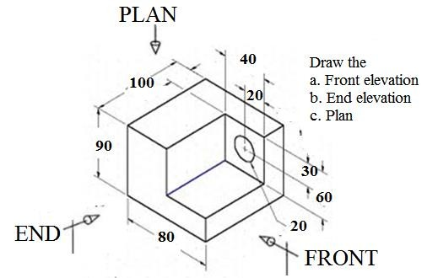 | Questions And Answers  Demonstration  V/E | Taking note of important points  Provide answers
Application | CLASS EXERCISE  Draw the following views in first angle projection (D & T page )  - The Front elevation looking in the direction of FE  - The End elevation looking in the direction of EE  - The Plan looking in the direction of P | Questions And Answers | Provide answers
Conclusion | • | V/E
LESSON EVALUATION

TEACHER:MWALE CHI

DESIGN AND TECHNOLOGY DEPARTMENT
LESSON PLAN

SUBJECT: DESIGN AND TECHNOLOGY CLASS:…… … DATE:……/……./20…. DURATION:………….
BOYS:…………………… GIRLS ………………………………………. TOTAL OF PUPILS:…………………… TOPIC: ORTHOGRAPHIC PROJECTION SUBTOPIC: ORTHOGRAPHIC PROJECTION LEARNING OUTCOMES LSBAT

Construct simple objects from isometric to Orthographic Projection with some hidden details
- Produce the End Elevation Third Angle Projection given the Plan and the Front Elevation.
RATIONALE
Knowledge Third Angle Projections,
Skills: Identification, Demonstration, Accuracy, Drawing, Communication
Values: Curiosity, Problem solving, Critical thinking, Application, Accuracy, Team work
TEACHING AIDS
PART | LESSON CONTENT | METHODOLO GY | LEARNER ACTIVITY
Introduction | - Recap on the previous lesson | Questions and answers | Provide answers
Developme nt | ISOMETRIC TO ORTHOGRAPHIC PROJECTION FIRS ANGLE PROJECTION  - Construct simple objects from isometric to Orthographic Projection with some hidden details  - Produce the End Elevation First Angle Projection given the Plan and the Front Elevation. | Questions And Answers  Demonstration  V/E | Taking note of important points  Provide answers
Application | CLASS EXERCISE  Draw the following views in first angle projection (D & T page )  - The Front elevation looking in the direction of FE  - The End elevation looking in the direction of EE  - The Plan looking in the direction of P | Questions And Answers | Provide answers
Conclusion | • | V/E
LESSON EVALUATION

TEACHER:MWALE CHI

DESIGN AND TECHNOLOGY DEPARTMENT
LESSON PLAN

SUBJECT: DESIGN AND TECHNOLOGY CLASS:…… … DATE:……/……./20…. DURATION:………….
BOYS:…………………… GIRLS ………………………………………. TOTAL OF PUPILS:…………………… TOPIC: ORTHOGRAPHIC PROJECTION SUBTOPIC: ORTHOGRAPHIC PROJECTION LEARNING OUTCOMES LSBAT

Construct simple objects from isometric to Orthographic Projection with some hidden details
- Produce the End Elevation First Angle Projection given the Plan and the Front Elevation.
RATIONALE
Knowledge: First and Third Angle Projections,
Skills: Identification, Demonstration, Accuracy, Drawing, Communication
Values: Curiosity, Problem solving, Critical thinking, Application, Accuracy, Team work
TEACHING AIDS
PART | LESSON CONTENT | METHODOLO GY | LEARNER ACTIVITY
Introduction | - Recap on the previous lesson | Questions and answers | Provide answers
Developme nt | ISOMETRIC TO ORTHOGRAPHIC PROJECTION FIRS ANGLE PROJECTION  - Construct simple objects from isometric to Orthographic Projection with some hidden details  - Produce the End Elevation First Angle Projection given the Plan and the Front Elevation.  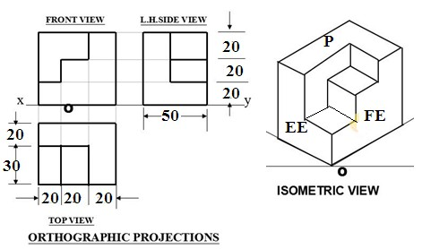 | Questions And Answers  Demonstration  V/E | Taking note of important points  Provide answers
Application | CLASS EXERCISE  Draw the following views in first angle projection (D & T page )  - The Front elevation looking in the direction of FE  - The End elevation looking in the direction of EE  - The Plan looking in the direction of P | Questions And Answers | Provide answers
Conclusion | • | V/E
LESSON EVALUATION

TEACHER:MWALE CHI

DESIGN AND TECHNOLOGY DEPARTMENT
LESSON PLAN

SUBJECT: DESIGN AND TECHNOLOGY CLASS:…… … DATE:……/……./20…. DURATION:………….
BOYS:…………………… GIRLS ………………………………………. TOTAL OF PUPILS:…………………… TOPIC: ORTHOGRAPHIC PROJECTION SUBTOPIC: THIRD ANGLE PRJOCTION
LEARNING OUTCOMES LSBAT

Construct simple objects from isometric to Orthographic Projection with some hidden details
- Produce the End Elevation Third Angle Projection given the Plan and the Front Elevation.
RATIONALE
Knowledge: Third Angle Projections,
Skills: Identification, Demonstration, Accuracy, Drawing, Communication
Values: Curiosity, Problem solving, Critical thinking, Application, Accuracy, Team work
TEACHING AIDS
PART | LESSON CONTENT | METHODOLO GY | LEARNER ACTIVITY
Introduction | - Recap on the previous lesson | Questions and answers | Provide answers
Developme nt | ISOMETRIC TO ORTHOGRAPHIC PROJECTION THIRD ANGLE PROJECTION  - Construct simple objects from isometric to Orthographic Projection with some hidden details  - Produce the End Elevation First Angle Projection given the Plan and the Front Elevation. | Questions And Answers  Demonstration  V/E | Taking note of important points  Provide answers
Application | CLASS EXERCISE  Draw the following views in THIRD angle projection (D & T page )  - The Front elevation looking in the direction of FE  - The End elevation looking in the direction of EE  - The Plan looking in the direction of P | Questions And Answers | Provide answers
Conclusion | - Recap on the main points and steps | V/E
LESSON EVALUATION

TEACHER:MWALE CHI

DESIGN AND TECHNOLOGY DEPARTMENT
LESSON PLAN

SUBJECT: DESIGN AND TECHNOLOGY CLASS:…… … DATE:……/……./20…. DURATION:………….
BOYS:…………………… GIRLS ………………………………………. TOTAL OF PUPILS:…………………… TOPIC: ORTHOGRAPHIC PROJECTION
SUBTOPIC: SECTIONAL DRAWING
LEARNING OUTCOMES LSBAT

Produce a sectional elevation in either First or Third angle given the cutting plane.
- Projection of elevations, plans cutting plane, sectioning, section subtitle, Hatching lines, Sectioning of.
RATIONALE
Knowledge: Sectioning of webs and curved surfaces
Skills: Identification, Demonstration, Accuracy, Drawing, Communication
Values: Appreciation, Application, Problem solving
TEACHING AIDS
PART | LESSON CONTENT | METHODOL OGY | LEARNER ACTIVITY
Introduction | - Recap on the previous lesson | Questions and answers | Provide answers
Developme nt | SECTIONAL DRAWING  Cutting plane x-x  Draw the following views in first angle projection  - Sectional Front elevations looking in the direction of arrow FE  - End elevation looking in the direction of arrow EE  - The plan looking in the direction of arrow P  - Insert any three important dimension  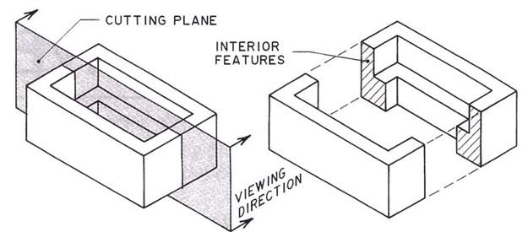 | Questions And Answers  Demonstratio n  V/E | Taking note of important points  Provide answers
Application | CLASS EXERCISE/ HOMEWORK  Draw the following views in first angle projection  - Sectional Front elevations looking in the direction of arrow FE  - End elevation looking in the direction of arrow EE  - The plan looking in the direction of arrow P  - Insert any three important dimension | Questions And Answers | Provide answers
Conclusion | - Recap on the main steps and points | V/E

LESSON EVALUATION

TEACHER:MWALE CHI

DESIGN AND TECHNOLOGY DEPARTMENT
LESSON PLAN

SUBJECT: DESIGN AND TECHNOLOGY CLASS:…… … DATE:……/……./20…. DURATION:………….
BOYS:…………………… GIRLS ………………………………………. TOTAL OF PUPILS:…………………… TOPIC: ORTHOGRAPHIC PROJECTION
SUBTOPIC: SECTIONAL DRAWING
LEARNING OUTCOMES LSBAT

Produce a sectional elevation in either First or Third angle given the cutting plane.
- Projection of elevations, plans cutting plane, sectioning, section subtitle, Hatching lines, Sectioning of.
RATIONALE
Knowledge: Sectioning of webs and curved surfaces
Skills: Identification, Demonstration, Accuracy, Drawing, Communication
Values: Appreciation, Application, Problem solving
TEACHING AIDS
PART | LESSON CONTENT | METHODOL OGY | LEARNER ACTIVITY
Introduction | - Recap on the previous lesson | Questions and answers | Provide answers
Developme nt | SECTIONAL DRAWING  Cutting plane x-x  Draw the following views in first angle projection  - Sectional Front elevations looking in the direction of arrow FE  - End elevation looking in the direction of arrow EE  - The plan looking in the direction of arrow P  - Insert any three important dimension  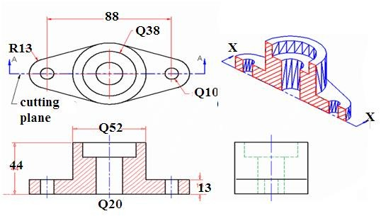 | Questions And Answers  Demonstratio n  V/E | Taking note of important points  Provide answers
Application | CLASS EXERCISE/ HOMEWORK  Draw the following views in first angle projection  - Sectional Front elevations looking in the direction of arrow FE  - End elevation looking in the direction of arrow EE  - The plan looking in the direction of arrow P  - Insert any three important dimension | Questions And Answers | Provide answers
Conclusion | - Recap on the main steps and points | V/E
LESSON EVALUATION

